**World Communion Sunday**

**Sunday, October 5, 2025**

**Liturgist:** **Sis. Violet Thom**

**Media Team: Tynisa Caesar, Sanville Vernon, Barnet Moriah**

**Praise Team: Alana Chang, LaTanya Davis, Hugh Fletcher**

**Organist: L. Daniel Jean /Drummer: Maurice Facey**

**Pastor: Dr. Andrea Smith**

**PRELUDE: Organist Daniel Jean**

**WELCOME: Sis. Violet Thom**

**CALL TO WORSHIP:**

One: In a world that remains divided and in conflict, God is inviting us, to make us one.  
**Many: Today we gather around one table, in answer to God’s will.**  
One: What do we find at today’s table?  
**Many: God’s love, which endures all things and connects all things.**  
  
One: What is not at today’s table?  
**Many: The many powers of the world, which seek to stand over others.**  
  
One: Let us repent and give thanks to God’s power to bring salvation to all who believe.  
**Many: Thanks be to God!  Make us witnesses of Your love.**  
  
**All: Let us worship together the true God, who makes us one.**

**OPENING HYMN: “I Know Whom I Believed ” UMH # 714**

**OPENING PRAYER:**

For the gift of faith which sees beyond the present moment and looks to an eternity,

we thank you. For the gift of faith small as a mustard seed, which has power within its simplicity, we thank you. For the gift of faith bestowed on those who would simply come, hearts open in humility, we thank you. Amen

**PRAISE and WORSHIP: “Alpha and Omega, We come this far by Faith”**

**WELCOME OF VISITORS AND PASSING THE PEACE:**

**CHURCH NOTICES**

**HAPPY BIRTHDAY/WEDDING ANNIVERSARIES**

**MISSION STATEMENT:**

**As Disciples of Jesus Christ, our Mission is to be:**

**Demonstrators of His Love,**

**Messengers of His Gospel,**

**and Sharers of His Teachings.**

**TIME OF GIVING:**

**We welcome your Tithes and Offerings today as we honor the Lord through our giving. Offerings can be given through various ways: give to an Usher, deposit in the offering basket, drop off in the church mailbox or through PayPal or Zelle. If you are using Zelle please enter bethanyunitedbklyn@gmail.com to find us.**

**OFFERTORY: (MARCHING) Follow the Ushers' directions.**

**OFFERTORY HYMN: “O Magnify the Lord”**

**DOXOLOGY: “Blessed Be the Name” UHM# 63**

**PRAYER OF DEDICATION:**

Faithful God, our source and sustainer, you call us to believe beyond what we see and serve without seeking reward. Take these gifts as seeds of trust, planted in hope and watered with gratitude. Even when our faith feels small, you multiply our offering into acts of healing, welcome, and justice. So, increase not only our faith, Lord, but also our willingness to serve—with humility, joy, and confidence that you are at work through every generous act. In the name of the one who came to serve, we pray. Amen.

**SCRIPTURE READINGS: Zachary Gordon Old Testament:** Lam 1:1-6; 3:19-26

**New Testament:** Luke 17:5-10

**The word of God for the people of God. Thanks be to God.**

**GLORIA PATRI: “Turn Your Eyes Upon Jesus” UMH# 349**

**HYMN: “Stand Up, Stand Up for Jesus” UMH# 514**

**SERMON:**  **Dr. Andrea Smith, Pastor**

**COMMUNION HYMN:** **“My Faith Looks Up to Thee” UMH# 452**

**COMMUNION: Pgs: # 7-11**

**ALTAR CALL HYMN: “It’s Me, It’s Me, O Lord” UMH# 352**

**PASTORAL PRAYER: Dr. Andrea Smith, Pastor**

**CLOSING HYMN: “Standing on the Promises” UMH# 374**

**BENEDICTION: Dr. Andrea Smith, Pastor**

Imagine what a mustard seed of faith might do this week in your life. Not a quart, nor a gallon, nor a truckload. Just a mustard seed. Imagine. Now go and live out that grace. Yes! Let it be so! Amen!

**LECTIONARY READING FOR THE WEEK:**

Lamentations 1:1-6

Psalm 137

2 Timothy 1:1-14

Luke 17:5-10

***Thank you for worshiping with us.***

**Announcements**

**From the Pastor’s Desk: Our annual Lay Leadership Training will be taking place via Zoom on Saturday, February 14, from 9:00 a.m. to 1:00 p.m. This is a MANDATORY MEETING for all chairpersons and co-chairpersons (committee members are welcome). Please save the date.**

**Bible Study has resumed on Wednesdays with day and evening groups.  For the Fall, we will be using the book "The Lord's Prayer" by Mary Lou Redding. The Zoom info: Meeting ID# 84334206486 & Passcode: 099590.**

**To call in dial: 646 931 3860**

Sunday School had resumed for children of ALL ages. Sunday School begins at 10 am.

**Our Charge Conference is scheduled for Saturday, November 1, at 10:00 a.m. at John Wesley UMC, 260 Qunicy Street. All end-of-year reports are due by Sunday, October 12th.**

**The Children’s Saturday Program has begun. All children are welcome. The program begins at 10 am.**

**Bethany’s Support Group will be available for support.**

**Prayers and conversation on the 2nd and 4th Sundays after church.**

Let's Pray Together. Join us every Wednesday Morning at 6:00 am on the Conference Call. Tel # 267-807-9601 Access code 843974659#

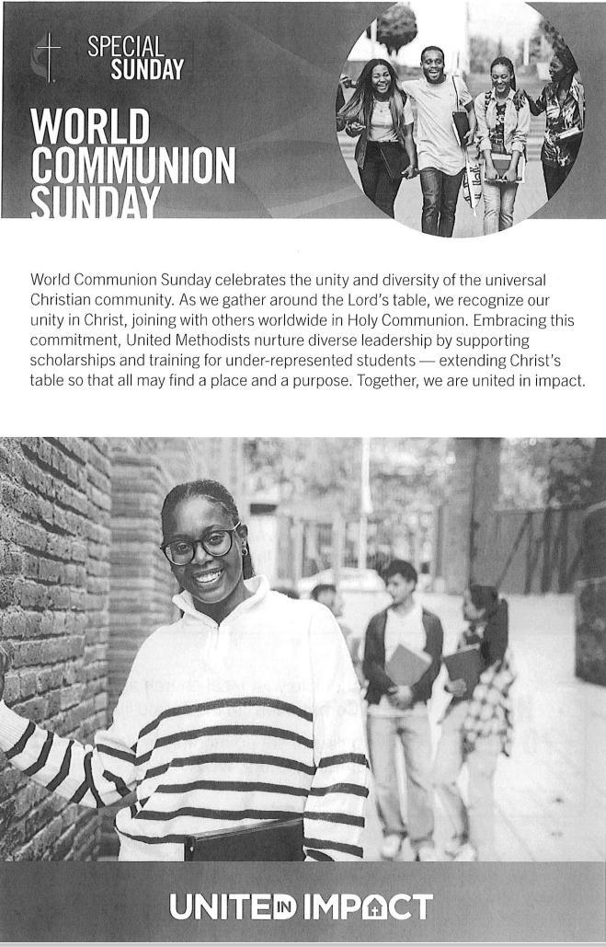

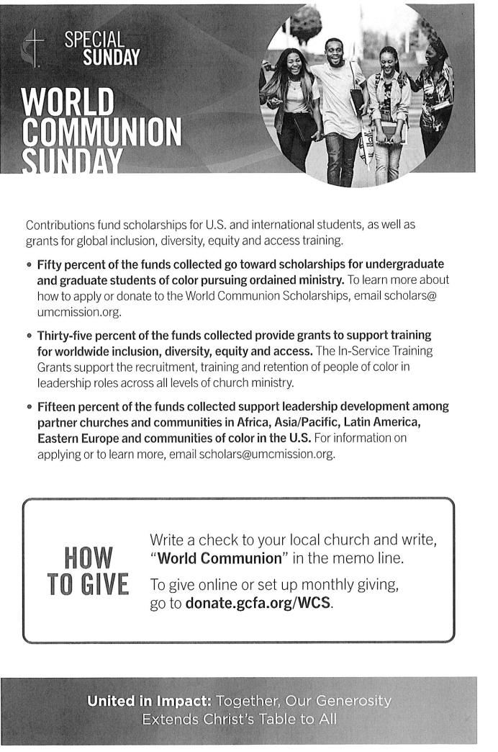

|  |  |  |  |  |  |  |  |  |  |  |  |  |  |
| --- | --- | --- | --- | --- | --- | --- | --- | --- | --- | --- | --- | --- | --- |
| **October** | | | | | | | | | | | | **2025** | |
|  | | | | | | | | | | | |  | |
| **Sunday** | **Monday** | | | **Tuesday** | **Wednesday** | | | **Thursday** | **Friday** | | | | **Saturday** |
|  |  | | |  | 1 | | | 2 | 3 | | | | 4 |
|  |  | | |  | **AA Meeting ( 7 pm – 8pm) every Wednesday** | | | **Thursday Dinner** |  | | | |  |
| 5 | 6 | | | 7 | 8 | | | 9 | 10 | | | | 11  **SOS Breakfast (9 - 12)** |
| **World Communion Sunday** |  | | |  |  | | |  |  | | | |  |
| 12 | 13 | | | 14 | 15 | | | 16 | 17 | | | | 18 |
|  |  | | |  |  | | |  | **Church Council – 7:30 pm** | | | | **United Women in Faith Trip** |
| 19 | 20 | | | 21 | 22 | | | 23 | 24 | | | | 25 |
| **Laity Sunday**  **Class member**  **Sister Davis Birthday Celebration** |  | | |  |  | | |  |  | | | |  |
| 26 | 27 | | | 28 | 29 | | | 30 | 31 | | | |  |
| **Reformation Sunday** |  | | |  |  | | |  |  | | | |  |
|  |  | | |  |  | | |  |  | | | |  |
|  |  | | |  |  | | |  |  | | | |  |
|  | |  | | | |  | | | | |  | | |
|  | | |  | | | |  | | |  | | | | |

|  |  |  |  |  |  |  |  |
| --- | --- | --- | --- | --- | --- | --- | --- |
| **November** | | | | | | **2025** | |
|  | | | | | |  | |
| **Sunday** | **Monday** | **Tuesday** | **Wednesday** | **Thursday** | **Friday** | | **Saturday** |
|  |  |  |  |  |  | | 1 |
|  |  |  | **AA Meeting ( 7 pm – 8pm) every Wednesday** |  |  | | **Charge Conference – 10 am** |
| 2 | 3 | 4 | 5 | 6 | 7 | | 8 |
| **Daylight Savings Time ends** (fall back one hour) |  |  |  | **Thursday Dinner** |  | |  |
| 9 | 10 | 11 | 12 | 13 | 14 | | 15 |
| **Anniversary Sunday** |  |  |  |  |  | | **United Women in Faith** |
| 16 | 17 | 18 | 19 | 20 | 21 | | 22 |
|  |  |  |  |  |  | |  |
| 2**3** | 24 | 25 | 26 | 27 | 28 | | 29 |
| **Harvest**  **Thanksgiving Sunday** |  |  |  | **Thanksgiving** |  | |  |
| 30 |  |  |  |  |  | |  |
| **First Day of Advent**  **UM Student Day** |  |  |  |  |  | |  |