Sunday, November 16, 2025
Liturgist: Sis. Mayleen Fredrick
Media Team: Tynisa Caesar, Sanville Vernon, Barnet Moriah
Praise Team: Alana Chang, LaTanya Davis, Hugh Fletcher
Organist: L. Daniel Jean /Drummer: Maurice Facey
Pastor: Dr. Andrea Smith

PRELUDE: Organist Daniel Jean

WELCOME: Sis. Mayleen Fredrick

*CALL TO WORSHIP:

L: Celebrate and rejoice, all you people of Christ,
Women: For the Lord our God is doing a new thing!
Men: The old order is gone,
All: Everything is new!

L: Illness, disease, crying, and mourning,
Women: Shall be as a distant memory!
Men: Hatred and war shall cease from the earth,
All: For Christ has risen! Death is defeated!
Hallelujah! Jesus lives!
Hallelujah! Amen.

OPENING HYMN: “This is the Day the Lord Hath Made” UMH # 658

OPENING PRAYER:
O God, we are more like the vision in Luke than the vision of Isaiah. We see wars, hatred, and violence everywhere, yet despair of ever stopping them. We see oppression, injustice, and persecution, but fail to raise our voices in prophetic protest. We have become a pessimistic people. Help us believe—really believe—
in Isaiah’s vision of the peaceable kin-dom, in your promise of a new heaven and new earth. Let your cry be our cry: “They shall not hurt or destroy on all my holy mountain.” Amen.
PRAISE and WORSHIP: “The Lord is Blessing Me, You deserve the Glory, and When I think about the Lord”

WELCOME OF VISITORS AND PASSING THE PEACE:
CHURCH NOTICES
HAPPY BIRTHDAY/WEDDING ANNIVERSARIES

MISSION STATEMENT:
As Disciples of Jesus Christ, our Mission is to be:
Demonstrators of His Love,
Messengers of His Gospel,
and Sharers of His Teachings.

A SPOKEN WORD: Minister Alton Treadwell

TIME OF GIVING:
We welcome your Tithes and Offerings today as we honor the Lord through our giving. Offerings can be given through various ways: give to an Usher, deposit in the offering basket, drop off in the church mailbox, or through PayPal or Zelle. If you are using Zelle please enter bethanyunitedbklyn@gmail.com to find us.

OFFERTORY: (MARCHING) Follow the Ushers' directions.

OFFERTORY HYMN: “We are climbing Jacob’s Ladder” UMH# 418

DOXOLOGY: “Give Thanks with a Grateful Heart”

PRAYER OF DEDICATION:
Lord of peace and serenity, receive the gifts we bring this day as we present them in thankfulness and joy. We bring ourselves as our offering, that in living lives of truth, justice, honor, and excellence, we might please you and be worthy of your never-failing love and presence with us. Grateful that Christ and the Holy Spirit might dwell in us, we pray in Jesus’ holy name. Amen.
SCRIPTURE READINGS: Zachery Gordon
Old Testament: Isaiah 9:6 (NKJV)
New Testament: Luke 2:9-11 (NKJV)

The word of God for the people of God. Thanks be to God.

GLORIA PATRI: “Thank you, Lord” UMH# 84

SOLO: “Worthy” Sis. LaTanya Davis

SERMON: “Jesus Synonymous with Joy” Minister Alton Treadwell

SELECTION: “O Happy Day”

PASTORAL PRAYER: Minister Alton Treadwell

CLOSING HYMN: “Come, Christians, Join to Sing” UMH# 158

BENEDICTION:
Go forth into a world that needs new visions. Bring the message of hope and love,
of justice and peace, to all you meet. Live the dream. Make it a reality. Celebrate endings and new beginnings, challenges and promises. Live the new creation. Amen.

Liturgical Scriptures Reading for the Week:
Isaiah 65:17-25
Isaiah 12
2 Thessalonians 3:6-13
Luke 21:5-19
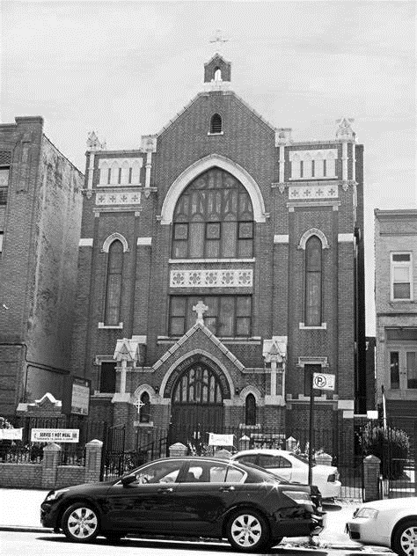
Thank you for worshipping with us.

