Sunday, December 21, 2025
Liturgist: Sis. Cynella Simon
Media Team: Tynisa Caesar, Sanville Vernon, Barnet Moriah
Praise Team: Alana Chang, LaTanya Davis, Hugh Fletcher
Organist: L. Daniel Jean /Drummer: Maurice Facey
Pastor: Dr. Andrea Smith

PRELUDE: Organist Daniel Jean

WELCOME: Sis. Cynella Simon

*CALL TO WORSHIP:

L: Beloved, God calls to us—like Joseph—through angels and messengers, inviting us to listen for the Spirit’s guidance in the midst of half-truths and distractions.
P: We listen faithfully for the day that all the earth awaits.

L: Sometimes, angels surprise us (as they did Mary) with good news too fantastical to believe and yet too real—realer than real—to ignore.
P: We listen faithfully for the day that all the earth awaits.

L: For generations, God has sent signs of God’s coming kingdom in unexpected places—the birth of a child, the wisdom of the lowly, the faithfulness of a carpenter.
P: We listen faithfully for the day that all the earth awaits.

L: Come! Let us worship God who calls out to us, inviting us to faithfulness as we watch, wait, and work for the day when the whole world knows the abundant love and grace of Emmanuel, God-with-us.
P: Come! Let us worship as we listen faithfully for the day that all the earth awaits.

OPENING HYMN: “Joy to the World” UMH # 246

OPENING PRAYER:
Gracious God, we thank You for bringing us together as one body in Christ. Today, we ask for unity among us, that we may love one another as You have loved us. Renew our minds, refresh our spirits, and restore our hope. Let this time of worship draw us closer to You and to each other, so that we may leave here ready to serve the world in Jesus' name. Amen.

WELCOME OF VISITORS AND PASSING THE PEACE:
CHURCH NOTICES
HAPPY BIRTHDAY/WEDDING ANNIVERSARIES

MISSION STATEMENT:
As Disciples of Jesus Christ, our Mission is to be:
Demonstrators of His Love,
Messengers of His Gospel,
and Sharers of His Teachings.

TIME OF GIVING:
We welcome your Tithes and Offerings today as we honor the Lord through our giving. Offerings can be given through various ways: give to an Usher, deposit in the offering basket, drop off in the church mailbox or through PayPal or Zelle. If you are using Zelle please enter bethanyunitedbklyn@gmail.com to find us.

OFFERTORY: (MARCHING) Follow the Ushers' directions.

OFFERTORY HYMN: “Go, Tell It on the Mountain” UMH# 251

DOXOLOGY: “Emmanuel, Emmanuel” UMH# 204

PRAYER OF DEDICATION:
Persistent God of new paths, we have been called to prepare the way—not with platitudes, but with changed hearts and lives. In this season of turning and anticipation, we offer these gifts as signs that we long to live by your story. Use them and use us to bear fruit worthy of repentance: fruit of justice, compassion, hospitality, and peace. Let our generosity reflect the nearness of your kingdom and the urgency of your call. In the wilderness of fear and want, may this offering clear a path for hope to be seen, known, and shared. In the name of the one who is coming and is already among us—Christ, our Lord. Amen.

SELECTION: Cathedral Choir

PRESENTATION OF CHILDREN/YOUTH
MINISTRY CHRISTMAS PROGRAM

CONGREGATIONAL PRAYER: Sis. Mayleen Frederick

CLOSING HYMN: “O Holy Night” Solo Bro. Hugh Fletcher

Liturgical Scriptures Reading for the Week:
Isaiah 7:10-16
Psalm 80:1-7, 17-19
Romans 1:1-7
Matthew 1:18-25

Announcements

The pastor would like to thank all for the gifts, cards, txt, and prayers sent to her for her birthday. It is greatly appreciated and made her day extra special.
Thank you.

The church office will only be open Monday & Tuesday from 9 am- 5 pm for the next 2 weeks. Thank you for your cooperation.

Please join us as we begin the New Year with 5 Hours of Prayer. Join us for a Virtual Shut-In Prayer beginning on Friday, January 2, @9pm through Saturday, January 3, @ 2 am

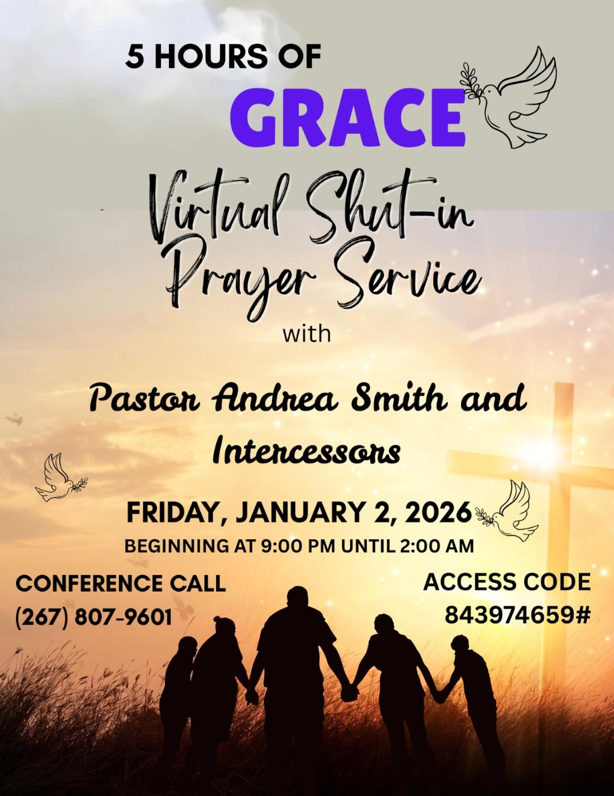

From the Pastor's Desk
All members, please make sure that the church has your current phone number. As we are in the winter season, if any changes are being made to Sunday Service, we will send out a telephone blast. If heavy snow is expected or if the temperature is below 30, Sunday Service will be held on Zoom (virtual).

From the Pastor’s Desk: Our annual Lay Leadership Training will be taking place via Zoom on Saturday, February 14, from 9:00 a.m. to 1:00 p.m. This is a MANDATORY TRAINING for all chairpersons and co-chairpersons (committee members are welcome). Please save the date.

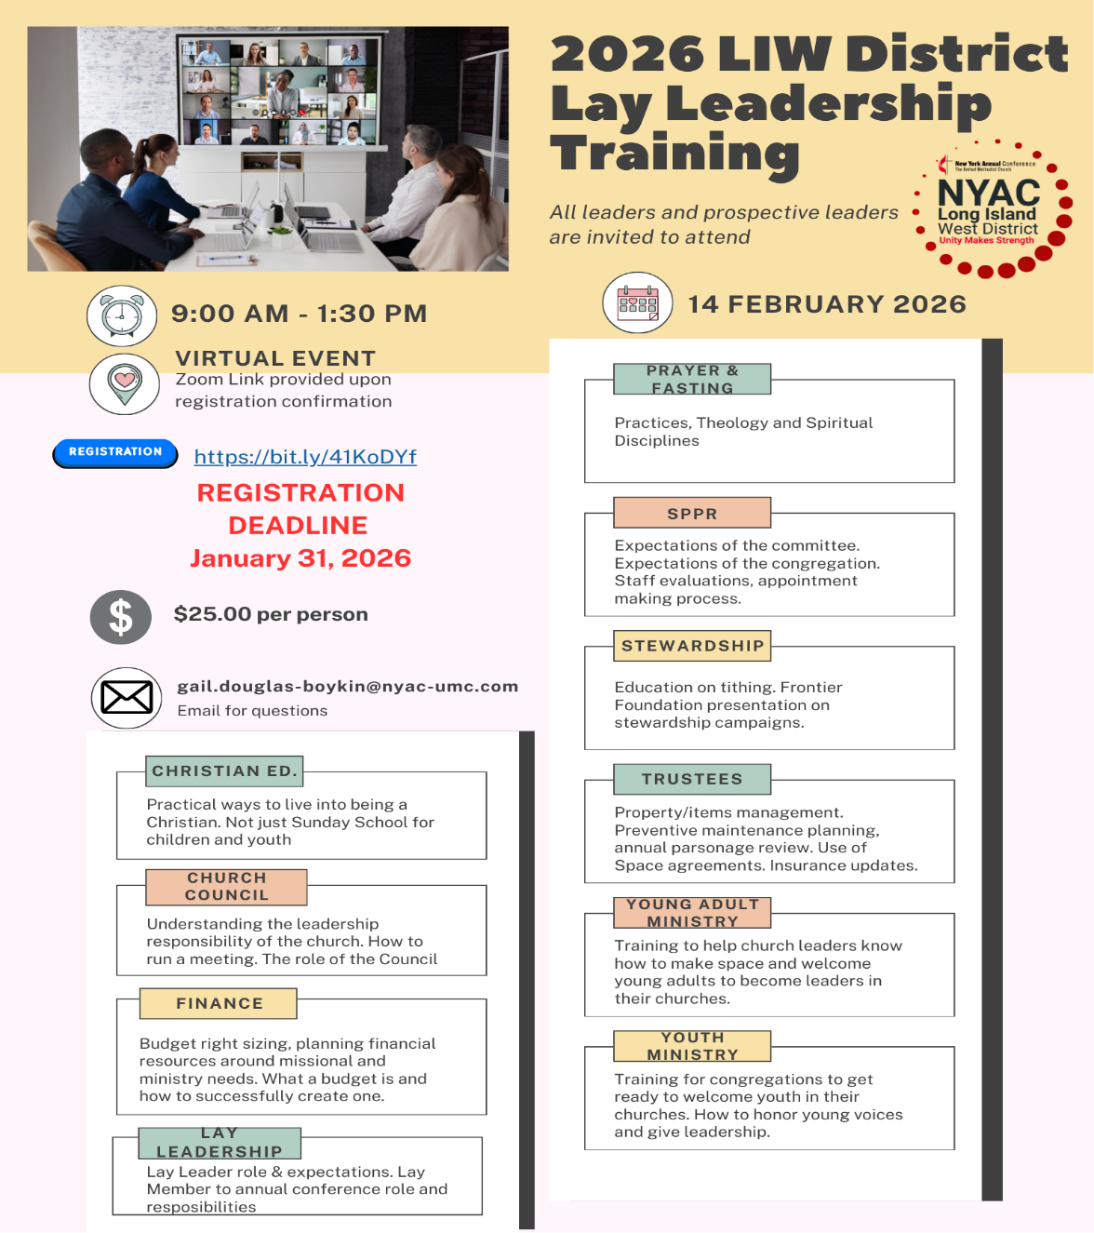
The Worship Committee is asking the congregation to check their immediate surroundings after the service and to pick up any candy wrappers, tissue paper, water bottles, and similar items before leaving the sanctuary.

It is that time of the year to beautify our church for the Holiday season with poinsettias. If you are interested in purchasing, please see anyone from finance or hospitality. The cost is $25 each.

All persons who joined Bethany in 2025, please call the Office to submit your name. Membership Certificates are being made.
The telephone is 718-774-5689.

Come and celebrate with us as we have a Christmas Eve Candlelight service
On Wednesday, December 24, at 7 pm here at Bethany.

Our Cooperative Parish will be having a joint Watch Night Service on Wednesday, December 31, at Newman UMC, 257 Macon Street. Beginning at 10:15 pm.

Time for our Youth to prepare themselves for confirmation. Parents, please see Deaconess Monica, Sis. Sharone or Bro. Thayne, concerning your child/children. We will begin classes in February. Please sign up early so proper preparations can be made for each person.

We invite you to our Advent Meditations. 30 days of celebrating the Presence of God until January 16. Join us from 7:00-7:30 am on the Conference Prayer Line.

Quest for Christ Fridays has resumed meetings from 6 pm to 8 pm. This is our Youth program for ages 13-18. All youth are welcome (from the church and the community).

Bible Study is on Wednesdays with day and evening groups. For the Fall, we will be using the book "The Lord's Prayer" by Mary Lou Redding. The Zoom info: Meeting ID# 84334206486 & Passcode: 099590
To call in, dial 646-931-3860. (There will not be any Bible study on Wednesday, 24 or the 31st)

Bethany’s Support Group will be available for support.
Join us for prayers and conversation on the 2nd and 4th Sundays after church.
Please meet with them at the front of the Sanctuary.

Let's Pray Together. Join us every Wednesday Morning at 6:00 am on the Conference Call. Tel # 267-807-9601 Access code 843974659#

Sick and Shut-In

Name | Telephone
Clemen Holder | N/A
Thelma Martin | 718-251-2903
Emily Isles | 718-346-0817
Eastlyn Welch | N/A
Pauline Osborne | Four Seasons
Grace Gyimah | 917-334-7105
Sandra Dubois | 718-774-4836
Jean Best | 718-778-4179
Amelia Cooper | 347-247-6067
Hilda Dyce | 718-251-6351
Pinkney Headley | 718-342-1056
Joyce Thompson | 718-649-6550
Sydney Campbell | 347-204-0850
Queenie Power | 917-215-2473
Una Wickham | 718-773-8645
Silvine Moore | 718-363-1091
Reginald Lawrence | 347-792-0159
Carmen Headley | 718-735-4189
Veronica Jackson | 934-867-9373
Cynthia Strachan | 347-262-1816
Winsome Johnson | Crown Heights Center 810 St. Mark’s Ave
Nevel Burnett | Brooklyn Downtown Nursing Home  727 Classon Ave

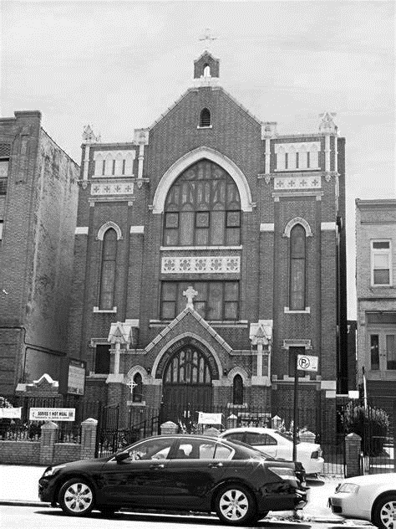
Thank you for worshiping with us.

