Sunday, January 11, 2026
Liturgist: Sis. Suginia Jones
Media Team: Tynisa Caesar, Sanville Vernon, Barnet Moriah
Praise Team: Alana Chang, LaTanya Davis, Hugh Fletcher
Organist: L. Daniel Jean /Drummer: Maurice Facey
Pastor: Dr. Andrea Smith

PRELUDE: Organist Daniel Jean

WELCOME: Sis. Suginia Jones

*CALL TO WORSHIP:
Liturgist: Come! Let us follow Jesus to the edge of the Jordan River to be baptized.
People: We come to be cleansed and made whole.
Liturgist: Come! Let us witness John’s confusion and Jesus’ insistence that John baptize God Incarnate.
People: We come to join Jesus in choosing life in the kingdom of God.

Liturgist: Come! Let us hear God declare the truth of Jesus’ identity and the truth of our identity as baptized people.
People: We come to remember and embody who we are as beloved children of God.

Liturgist: Come! Let us worship God who leads us into the baptismal waters and salvation life.
People: We come to worship God who empowers us through divine presence to live together as the family of God.

OPENING HYMN: “O Worship the King” UMH # 73

OPENING PRAYER:
Eternal God, at the baptism of Jesus, you revealed him to be your Son,
and anointed him with the Holy Spirit, Keep all who are born of water and the Spirit faithful to their calling as your people; through Jesus Christ our Lord, who lives and reigns with you and the Holy Spirit,
one God, now and for ever. Amen.
PRAISE and WORSHIP: “I Sing Praises Medley, You are God alone.”

WELCOME OF VISITORS AND PASSING THE PEACE:
CHURCH NOTICES
HAPPY BIRTHDAY/WEDDING ANNIVERSARIES

MISSION STATEMENT:
As Disciples of Jesus Christ, our Mission is to be:
Demonstrators of His Love,
Messengers of His Gospel,
and Sharers of His Teachings.

TIME OF GIVING:
We welcome your Tithes and Offerings today as we honor the Lord through our giving. Offerings can be given through various ways: give to an Usher, deposit in the offering basket, drop off in the church mailbox, or through PayPal or Zelle. If you are using Zelle please enter bethanyunitedbklyn@gmail.com to find us.

OFFERTORY: (MARCHING) Follow the Ushers' directions.

OFFERTORY HYMN: “Walking Up the King’s Highway” AHH# 402

DOXOLOGY: “Praise God, from Whom All Blessings Flow” UMH# 94

PRAYER OF DEDICATION:
Faithful and Calling God, continue to draw us into community, into covenant, and into new life through waters of grace and acts of justice. Just as Jesus stepped into the river to stand with us and for us, we bring these gifts today to stand with others—to serve, to uplift, and to proclaim your kingdom. Use these offerings to fulfill your righteousness among us. Help us, your baptized people, to be instruments of healing, hope, and holy change in a world longing for good news. In Christ’s name we pray, Amen.

SCRIPTURE READINGS:
Old Testament: Isa. 42:1-9
New Testament: Matt. 3:13-17

The word of God for the people of God. Thanks be to God.

GLORIA PATRI: “Halle, Halle, Halle” AAHH# 642

HYMN: “The Summons” FWS# 2130

SERMON: Dr. Andrea Smith, Pastor

HYMN: “Spirit Song ” AAHH# 321

PASTORAL PRAYER: Dr. Andrea Smith, Pastor

CLOSING HYMN: “Fairest Lord Jesus” AAHH# 189

BENEDICTION: Dr. Andrea Smith, Pastor

Go in peace; love and care for one another in the name of Christ; and may the Spirit of God, which filled John and Jesus, fill your hearts, souls, and minds;
may the power of God, which upheld them, strengthen you for each day; and may the love of God, which directed their every action, be your guiding light and your shining star, both now and forevermore. Amen

Pastor's New Hours will be Wednesdays and Fridays from 11 am- 4 pm beginning the week of January 19th.

Lectionary Scriptures Reading for the Week:
Isaiah 42:1-9
Psalm 29
Acts 10:34-43
Matthew 3:13-17
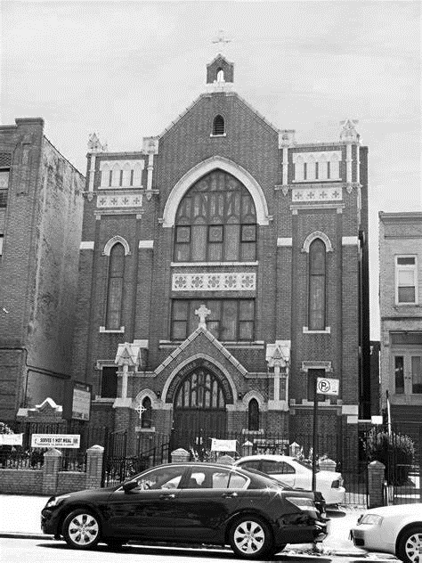
Thank you for worshipping with us.

