February 22, 2026
Liturgist: Sis. Norma Grant
Media Team: Tynisa Caesar, Sanville Vernon, Barnet Moriah
Praise Team: Alana Chang, LaTanya Davis, Hugh Fletcher
Organist: L. Daniel Jean /Drummer: Maurice Facey
Pastor: Dr. Andrea Smith

PRELUDE: Organist Daniel Jean

WELCOME: Sis. Norma Grant

*CALL TO WORSHIP:
Liturgist: Today, we follow Jesus into a wilderness full of isolation, fatigue, hunger, thirst, and temptation.
People: We follow, trusting in God’s mercy.

Liturgist: We witness Jesus resist the siren calls of sensationalism, notoriety, and misuse of power for selfish gain.
People: We recognize God’s mercy at work in the face of temptation.

Liturgist: We notice the angels who tend Jesus, messengers of care in a harsh and lonely place.
People: We pay attention to God’s merciful presence that did not abandon Jesus and does not abandon us now.

Liturgist: We come to the wilderness together, clinging to the truth that we are not alone—God is with us.
People: We gather to worship God, whose unfailing mercy journeys with us into the wildernesses of our lives. Thanks be to God! Amen.

OPENING HYMN: “O Worship the King” UMH # 73

OPENING PRAYER:
Holy God, by the grace of Jesus Christ, you know the tests and trials we face. Journey with us through this wilderness. Come to us with ministers of healing and visit us with messengers of hope, so that we may return to you in faith, believing the good news of the gospel; through Jesus Christ, our Savior. Amen.

PSALTER PSALM 32: Pg # 766

PRAISE and WORSHIP: “”

WELCOME OF VISITORS AND PASSING THE PEACE:
CHURCH NOTICES
HAPPY BIRTHDAY/WEDDING ANNIVERSARIES

MISSION STATEMENT:
As Disciples of Jesus Christ, our Mission is to be:
Demonstrators of His Love,
Messengers of His Gospel,
and Sharers of His Teachings.

TIME OF GIVING:
We welcome your Tithes and Offerings today as we honor the Lord through our giving. Offerings can be given through various ways: give to an Usher, deposit in the offering basket, drop off in the church mailbox, or through PayPal or Zelle. If you are using Zelle, please enter bethanyunitedbklyn@gmail.com to find us.

OFFERTORY: (MARCHING) Follow the Ushers' directions.

OFFERTORY HYMN: “I’m Goin’a Sing When the Spirit Sing” UMH# 333

DOXOLOGY: “My Tribute” UMH# 99

PRAYER OF DEDICATION:
Surprising God of Mercy, you meet us in wilderness places and walk beside us through trial and temptation. Even when we feel alone, your grace is never far, your presence never absent. In this moment of giving, we offer not just our resources, but our trust that you are already at work, shaping us through challenge, strengthening us through sacrifice, and surrounding us with unseen angels. Use these gifts to bring hope where there is hunger, healing where there is pain, and light where there is despair. May what we give reflect our desire to walk more closely with you, even in the hard places.
In Christ’s name we pray, Amen.
POEM: Caden Clarke

SCRIPTURE READINGS:
Old Testament: Gen. 2:13-17; 3:1-7
New Testament: Mt. 4:1-11

The word of God for the people of God. Thanks be to God.

GLORIA PATRI: “El Shaddai” UMH# 123

SOLO: Bro. Elder Hugh Fletcher

SERMON: Dr. Andrea Smith, Pastor

HYMN: “Amazing Grace” UMH# 378

PASTORAL PRAYER: Dr. Andrea Smith, Pastor

CLOSING HYMN: “Grace Greater than All Our Sin” UMH# 365

BENEDICTION : Dr. Andrea Smith, Pastor
Go, now, in the comfort and blessing of God’s mercy, trusting that wherever you go, God’s steadfast love surrounds you, sustains you, and supports you for the journey ahead. Amen.

Pastor's New Hours will be Wednesdays and Fridays from 11 am- 4 pm (weather permitting).

Liturgical Scriptures Reading for the Week:
Genesis 2:15-17; 3:1-7
Psalm 32
Romans 5:12-19
Matthew 4:1-11

Announcements
Join us Every Wednesday evening at 7 pm during the Lenten Season for Services on Zoom. Zoom info is 870 7785 5614
Passcode 271054 call in 646-558-8656

Join Pastor for a One Night Lenten Study on Prayer and Fasting on Friday, March 13, from 7 - 9 pm, Zoom 865 8901 0738, Passcode 537947call in 646-558-8656

Please notify any member of Finance how you would like to receive your financial statements.

Confirmation classes will begin soon. You must sign up TODAY to participate in the confirmation classes.

Please note that all announcements for the Sunday’s bulletin must be received by the office no later than Wednesday at noon.

Graduation season will soon be upon us! To get an early start, we are asking all members who have children, grandchildren, or relatives graduating in 2026 to please submit their names to Sis. Venice or Sis. Mayleen.
We look forward to celebrating our graduates and their achievements.

The Worship Committee is asking the congregation to check their immediate surroundings after the service and to pick up any candy wrappers, tissue paper, water bottles, and similar items before leaving the sanctuary.

Quest for Christ meets on Fridays from 6 pm to 8 pm. All youth between the ages of 13-18 are welcome (from the church and the community).
Bible Study is on Wednesdays, Daytime from 12:30 pm – 2 pm, and Evening Bible Study will meet on Tuesdays at 7:30 during the Lenten Season. The Zoom info: Meeting ID# 84334206486 & Passcode: 099590
To call in, dial 646-931-3860.

Bethany’s Support Group will be available for support.
Join us for prayers and conversation on the 2nd and 4th Sundays after church.
Please meet with them at the front of the Sanctuary.

Let's Pray Together. Join us every Wednesday Morning at 6:00 am on the Conference Call. Tel # 267-807-9601 Access code 843974659#

Sick and Shut-In
Name | Telephone
Clemen Holder | N/A
Thelma Martin | 718-251-2903
Emily Isles | 718-346-0817
Eastlyn Welch | N/A
Pauline Osborne | Four Seasons
Grace Gyimah | 917-334-7105
Sandra Dubois | 718-774-4836
Jean Best | 718-778-4179
Amelia Cooper | 347-247-6067
Hilda Dyce | 718-251-6351
Pinkney Headley | 718-342-1056
Joyce Thompson | 718-649-6550
Sydney Campbell | 347-204-0850
Queenie Power | 917-215-2473
Una Wickham | 718-773-8645
Silvine Moore | 718-363-1091
Reginald Lawrence | 347-792-0159
Carmen Headley | 718-735-4189
Veronica Jackson | 934-867-9373
Cynthia Strachan | 347-262-1816
Winsome Johnson | N/A
Nevel Burnett | Brooklyn Downtown Nursing Home  727 Classon Ave
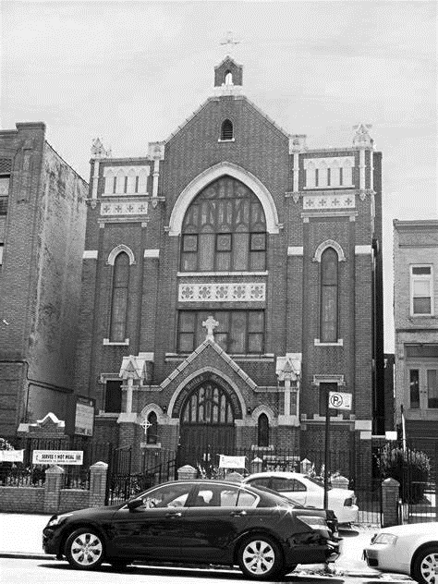
Thank you for worshipping with us.

