April 26, 2026
Liturgist: Sis. Mayleen Frederick
Media Team: Tynisa Caesar, Sanville Vernon, Barnet Moriah
Praise Team: Alana Chang, LaTanya Davis, Hugh Fletcher
Organist: L. Daniel Jean /Drummer: Maurice Facey
Pastor: Dr. Andrea Smith

PRELUDE: Organist Daniel Jean

WELCOME: Sis. Mayleen Frederick

*CALL TO WORSHIP:
Liturgist: Easter people, we gather to worship and to listen, to learn the sound, the feel, the cadence of the Shepherd’s voice.
People: We come seeking our Shepherd’s voice.

Liturgist: We gather to worship and to discern, to learn how to recognize our Shepherd’s voice amidst the chaos and noise of our lives.
People: We come seeking our Shepherd’s voice.

Liturgist: We gather to worship and to find shelter, to learn to trust our Shepherd’s voice to guide us to safety and provide for us in all things.
People: We come seeking our Shepherd’s voice.

Liturgist: Come, let us worship as we listen for the voice of Jesus who guides us, protects us, provides for us, and draws us together in community.
People: We come to worship as the family of Christ, a flock seeking and following our Shepherd’s voice. Amen.

OPENING HYMN: “He Rose” UMH# 316

OPENING PRAYER:
Loving Shepherd, you know our names; you care for us. When we face darkness and death, journey beside us. When we hunger for your love, fill us with your presence.
When we are fearful, feed us at your table. May we dwell in the house of goodness and mercy all the days of our lives. Amen.

PRAISE and WORSHIP: Way Maker, Breathe, Worthy of it All

MISSION STATEMENT:
As Disciples of Jesus Christ, our Mission is to be:
Demonstrators of His Love,
Messengers of His Gospel,
and Sharers of His Teachings.

WELCOME OF VISITORS AND PASSING THE PEACE:
CHURCH NOTICES
HAPPY BIRTHDAY/WEDDING ANNIVERSARIES

TIME OF GIVING:
We welcome your Tithes and Offerings today as we honor the Lord through our giving. Offerings can be given through various ways: give to an Usher, deposit in the offering basket, drop off in the church mailbox, or through PayPal or Zelle. If you are using Zelle, please enter bethanyunitedbklyn@gmail.com to find us.

OFFERTORY: (MARCHING) Follow the Ushers' directions.

OFFERTORY HYMN: “We’ve Come this Far by Faith”

DOXOLOGY: “God Is So Good” UMH# 156

PRAYER OF DEDICATION:
Faithful Shepherd, who calls us by name, you invite us into a life that is rich in meaning, deep in joy, and bold in compassion. You speak, and we long to follow—although the world is noisy and the path unclear. In this moment of offering, we quiet our hearts to listen again. Receive these gifts as signs of our trust in you. May they be used to bring abundance to others, to feed the hungry, to strengthen the lost, and to proclaim your voice of love. In coming and going, in worship and service, make us more like Christ, in whose name we give and pray. Amen.

SCRIPTURE READINGS:
Old Testament: Ezek. 34: 11-16, 20-34
New Testament: Rev. 3: 7-8
The word of God for the people of God. Thanks be to God.

GLORIA PATRI: “He Is Lord” UMH# 177

HYMN: “Easter People, Raise Your Voices” UMH# 304

SERMON: “The God who Goes Before You” Dr. Andrea Smith, Pastor

HYMN: “Savior, Like a Shepherd Lead Us” UMH# 381

PASTORAL PRAYER: Dr. Andrea Smith, Pastor

CLOSING HYMN: “The Battle Hymn of the Republic” UMH# 717

BENEDICTION : Dr. Andrea Smith, Pastor
Beloved, may God bless you with open hearts and minds so that together we may pay attention, discern, and follow your Shepherd’s voice, for that is the way that leads to abundant life on earth as it is in heaven. Amen.

Pastor's New Hours will be Wednesdays and Fridays from 11 am- 4 pm.

Liturgical Scriptures Reading for the Week:
Ezekiel 34:11-16, 20-34
Psalm 100
1 Peter 2:19-25
John 10:1-10

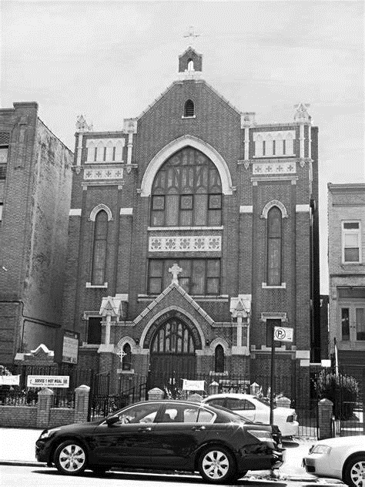
Thank you for worshipping with us.

