

Children/Youth Sunday, June 28, 2026
Liturgist: Bro. Kevin Jones
Media Team: Tynisa Caesar, Sanville Vernon, Barnet Moriah
Praise Team: Alana Chang, LaTanya Davis, Hugh Fletcher
Organist: L. Daniel Jean /Drummer: Maurice Facey
Pastor: Dr. Andrea Smith

PRELUDE: Organist Daniel Jean

WELCOME: Bro. Kevin Jones

*CALL TO WORSHIP:
Liturgist: When our way seems unclear, and we are surrounded by loud and conflicting voices…
People: God will provide.
Liturgist: When we, like Abraham, are trying to be faithful and seem to have no good choices available to us…
People: God will provide.
Liturgist: When we, like Isaac, are led by those we trust into unjust and harmful situations…
People: God will provide.
Liturgist: Family in Christ, we gather today to worship God, who meets us in places of fear, confusion, and despair.
People: We gather to worship God, who provides a way toward abundant life when no way can be found. Thanks be to God! Amen.

OPENING HYMN: “I Love to Tell the Story” UMH# 156

OPENING PRAYER:
Lord, the hearts of all turn to You in hope; and You give them what they need.
You open Your hand and satisfy the hunger and thirst of every living thing.
We, too, turn to You again, longing to be filled—to eat of the Bread of Life,
to drink from Your life-giving streams, to taste Your goodness and live.
May the time we spend together in Your presence nourish our hearts and minds; may it strengthen our relationship with You, and renew our commitment to live in this world as Your faithful disciples. For You alone are God, the Source and Sustainer of life. In Jesus’ name, Amen.
PRAISE and WORSHIP: I will Praise Thee, Oh Lord, I really love the Lord,
Where Feet May Fail

WELCOME OF VISITORS AND PASSING THE PEACE:
CHURCH NOTICES
HAPPY BIRTHDAY/WEDDING ANNIVERSARIES

SATURDAY PROGRAM/SUNDAY SCHOOL PRESENTATION

QUEST FOR CHRIST PRESENTATION (Summary of Learning)

TIME OF GIVING:
We welcome your Tithes and Offerings today as we honor the Lord through our giving. Offerings can be given through various ways: give to an Usher, deposit in the offering basket, drop off in the church mailbox, or through PayPal or Zelle. If you are using Zelle, please enter bethanyunitedbklyn@gmail.com to find us.

OFFERTORY: (MARCHING) Follow the Ushers' directions.

OFFERTORY HYMN: “This Little Light of Mine” UMH# 585

DOXOLOGY: “Jesus, Remember Me” UMH# 488

PRAYER OF DEDICATION:
Faithful Provider, we bring our gifts with trembling hands and trusting hearts. Like Abraham on the mountain, we don’t always understand the path ahead, but we believe in your promise: that you will provide. We offer these gifts, not as bargains or sacrifices to earn your love, but as signs of our trust in you. Use them, we pray, to bless others—to meet needs, to heal hurts, to build hope. And as you provide for the world through us, keep us faithful to your calling, even when the way is unclear. May our giving be our “Here I am,” ready and willing to serve. In Christ’s name, Amen.

MISSION STATEMENT: (please remain standing)
As Disciples of Jesus Christ, our Mission is to be:
Demonstrators of His Love,
Messengers of His Gospel,
and Sharers of His Teachings.
SCRIPTURE READINGS:
Old Testament: Gen. 22:1-14
New Testament: Rom. 6:12-23
The word of God for the people of God. Thanks be to God.

GLORIA PATRI: “Lead Me, Lord” UMH # 473

HYMN: “Jesus loves Me, This I Know” UMH # 191

BAPTISM: UMH pgs. 39-43

YOUTH MESSAGE: “It‘s up to you to pass the test” Sis. Ellah Jones

ACKNOWLEDGMENT OF GRADUATES:

HYMN: “I Want Jesus to Walk with Me” UMH# 521

PASTORAL PRAYER Dr. Andrea Smith, Pastor

CLOSING HYMN: “What a Fellowship” UMH# 133

BENEDICTION : Dr. Andrea Smith, Pastor
May God go with you, blessing you with divine provision, making paths where there were none before, and leading you into flourishing in the most impossible of places. Amen.

Lectionary Scriptures Reading for the Week:
Genesis 22:1-14
Psalm 13
Romans 6:12-23
Matthew 10:40-42



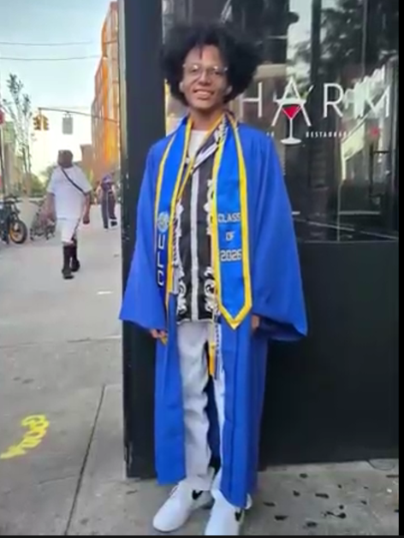

Zachary Gordon is a humble and respectful 13 year old boy who has a sincere reverence for God. Though he has his challenges, he continues to push through with grace and a gentle Spirit. His life reflects the truth of Psalm 27:13, he “will see the goodness of the Lord in the land of the living”. God’s hand is on his future. Zachary transitions from the Medgar Ever Preparatory Middle School, into the High School.
Announcements

HAPPY INDEPENDENCE DAY, DOMINICA

To: The Bethany Family
Sister Patricia Holder and the Holder Family thank you for the sympathy, love, and support extended to them during their time of sorrow. It is greatly appreciated and will always be remembered.
Again, thank you, and God Bless You All

Beginning July 12, we will begin our Summer session. Service will be at 10 am for the Summer.

Inviting all those who participated in Bible study this year to join us on Saturday, July 18 @1pm for a time of reflection and fellowship. It will be a potluck meal. Bring your favorite finger foods and drinks.

We will have our Confirmation Service on Sunday, July 12, at the 10 am service. Please come out and celebrate our Confirmands and their families.

Church Family,
Bethany United Methodist Church will host its Meet the Community Prayer Outreach on Saturday, July 11, 2026, from 12:00 PM to 3:00 PM. During this event, we will be out in the community offering prayer, encouragement, spiritual support, fellowship, welcome bags, and information about the ministries of our church. Our goal is to connect with our neighbors, listen to their concerns, and share the love and hope of Jesus Christ.
Flyers are available downstairs on the entrance table. Please take a few copies and share them with your family, friends, neighbors, coworkers, and anyone who may be interested. Your invitation could be the encouragement someone needs. Thank you for helping us reach our community and live out our mission to be demonstrators of Christ's love, messengers of His gospel, and sharers of His teachings.
"Come. Connect. Pray. Belong."
A Ministry Initiative of the Evangelism Committee, Support Group, and SPPRC Committee.
Thank you
Sis Nicole

Come one and all to the May/June (Zebulun/Issachar) Birthdays Fundraising Walk-a-Thon event “Walking For Jesus” on Saturday, July 11, 2026 (rain check July 18th) from Bethany via Eastern Parkway to Grand Army Plaza. A sign-up donation is welcome!!
We look forward to your participation and support!!
Thanks

We propose a cruise around Manhattan on Saturday, September 19, 2026. We ask everyone interested in joining this Brunch Cruise to please submit their names along with a deposit as soon as possible. This is important because we need to contact the cruise line to make a reservation and arrange transportation with a bus company. The cost is $200 for adults and $180 for children under 12. The contact persons for this event are Sister Yvette and Sister Norma. Thank you

The Hunger Program is asking for donations of wire hangers, as many as you can spare. Thank you

The July/August Birthdays are hosting a trip to Woodbury Commons Shopping Outlets and Catskills Resorts World on Saturday, September 5th. Cost is $100 per ticket. Seats are limited, so get your ticket before they sell out! Thank you!

The pastor is asking all members to please take note that when you are sick/hospitalized, or have a death in the family, please call the office and notify the church so the pastor can be made aware of it.

For all Bethany events, all programs must be seen and approved by the Pastor.

The Twelve Tribes Blessing Drive has begun. If you haven't signed up with your birthday information, please see the list and sign up with your coordinator. Thank you.
The Coordinators for the Twelve Tribes Blessing Drive are:
Judah/Simeon (Jan/Feb)-GAYLENE FRANCIS
Levi/Reuben (Mar/Apr)-ALICIA GRANT
Zebulun/Issachar (May/Jun)-NORMA GRANT
Dan/Gad (Jul/Aug)—SUGINIA JONES
Asher/Naphtali (Sep/Oct)-BEATRIZ SHERWOOD
Joseph (Ephraim and Manasse) Benjamin (Nov/Dec)-MAHALIA NURSE & YVETTE DICK-MCKAIN

Women’s Day Events
1) Bethany Cruise - September 19th
an exciting brunch cruise around Manhattan on the Spirit of New York.
The cost of the cruise is $200.00 per adult and $180.00 for children under 12.
Secure your seat by making a deposit. Deposits are being taken by Sister Norma and Sister Yvette
2) Prayer Breakfast- Saturday, Oct. 24th
Team – Sis. Mayleen Frederick, Sis. Violet Thom

Sick and Shut-In
Name | Telephone
Emily Isles | 718-346-0817
Eastlyn Welch | N/A
Grace Gyimah | 917-334-7105
Sandra Dubois | 718-774-4836
Jean Best | 718-778-4179
Hilda Dyce | 718-251-6351
Pinkney Headley | 718-342-1056
Joyce Thompson | 718-649-6550
Sydney Campbell | 347-204-0850
Una Wickham | 718-773-8645
Silvine Moore | 718-363-1091
Reginald Lawrence | 347-792-0159
Carmen Headley | 718-735-4189
Veronica Jackson | 934-867-9373
Cynthia Strachan | 347-262-1816
Winsome Johnson | N/A

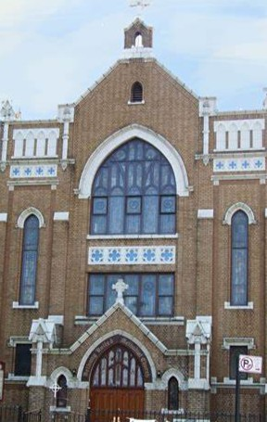

Thank you for worshipping with us.

