June 7, 2026
Liturgist: Sis. Norma Grant
Media Team: Tynisa Caesar, Sanville Vernon, Barnet Moriah
Praise Team: Alana Chang, LaTanya Davis, Hugh Fletcher
Organist: L. Daniel Jean /Drummer: Maurice Facey
Pastor: Dr. Andrea Smith

PRELUDE: Organist Daniel Jean

WELCOME: Sis. Norma Grant
*CALL TO WORSHIP:
Liturgist: Like Abram and Sarai, God calls us to go into the unknown, trusting that God’s promises are true.
People: Whether we are certain or full of doubts, God blesses us that we may be a blessing.

Liturgist: God sends us into the world to journey by faith, believing that God’s blessings are greater than anything we can imagine.
People: Whether the path is straight or winding, God blesses us that we may be a blessing.

Liturgist: God gathers us today with trusted companions, those who also follow God’s call, even when it does not make sense to the world around us.
People: Whether we journey with friends or feel all alone, God blesses us that we may be a blessing.
Liturgist: As we gather to worship, may we remember that we are God’s people, blessed by God to be a blessing to our world that is hurting and desperately in need of good news.
People: God, form us today as a family of faith, that your blessings might flow out of us and into our world, drawing all people into your promise of abundant life and flourishing. Amen.

OPENING HYMN: “A Mighty Fortress is Our God” UMH# 110
OPENING PRAYER:
Long before the change of name, before the first signs of new life showed the beginnings of promises fulfilled, You asked Abram to make his home among foreigners, and share the blessing that was to come. And now, O God, you ask the same faith of us: The faith to count ourselves among the least, to find our place alongside the poor and broken; The faith to trust in your mercy and your promises, and to share what we have received; The faith to wait expectantly for your reign of justice and equity, together with those who most need its gifts.
Teach us to be children of Abram, sharers of the blessings we enjoy: The blessing of plenty shared with those who have need, The blessing of healing shared with those who are sick and wounded, The blessing of joy shared with those who celebrate and of tears shared with those who grieve, The blessing of friendship shared with those who are excluded, and of solidarity with those who fight injustice, The blessing of peace shared with those in conflict, and of confrontation shared with those who bring harm; And in some small way, may our faith and our sharing, help to bring your promises into being in our world.
Amen.

PRAISE and WORSHIP: Praise Is What I Do, You Deserve It

MISSION STATEMENT: (please remain standing)
As Disciples of Jesus Christ, our Mission is to be:
Demonstrators of His Love,
Messengers of His Gospel,
and Sharers of His Teachings.

WELCOME OF VISITORS AND PASSING THE PEACE:
CHURCH NOTICES
HAPPY BIRTHDAY/WEDDING ANNIVERSARIES

TIME OF GIVING:
We welcome your Tithes and Offerings today as we honor the Lord through our giving. Offerings can be given through various ways: give to an Usher, deposit in the offering basket, drop off in the church mailbox, or through PayPal or Zelle. If you are using Zelle, please enter bethanyunitedbklyn@gmail.com to find us.

OFFERTORY: (MARCHING) Follow the Ushers' directions.

OFFERTORY HYMN: “This Little Light of Mine” UMH# 585

DOXOLOGY: “Jesus, Remember Me” UMH# 488

PRAYER OF DEDICATION:
Calling God, you spoke to Abram and set him on a journey, not with full clarity, but with full trust. You promised blessing—and with it, purpose. We come now as your people, also journeying by faith, offering these gifts not for our greatness, but so that your promise might be fulfilled through us: to bless the world. Use these offerings to build relationships, to mend the broken, and to draw all families of the earth toward your heart. May our giving reflect our trust, and may our trust lead us to go where you send, step by step, stage by stage, into your future. Amen.

SCRIPTURE READINGS:
Old Testament: Gen. 12:1-9
New Testament: Mt. 9:9-18; 18-26
The word of God for the people of God. Thanks be to God.

GLORIA PATRI: “Lead Me, Lord” UMH# 473

HYMN: “He Leadeth me: O Blessed Thought” UMH# 128

SERMON: “ Journey into the Unknown” Sis. Mayleen Frederick

HYMN: “ Only Trust Him” UMH# 337

PASTORAL PRAYER

CLOSING HYMN: “God Will Take Care of You” UMH# 130

BENEDICTION :
Go now as the people
e of God, a family.

Lectionary Scriptures Reading for the Week:
Genesis 12:1-9
Psalm 33:1-12
Romans 4:13-25
Matthew 9:9-13, 18-26
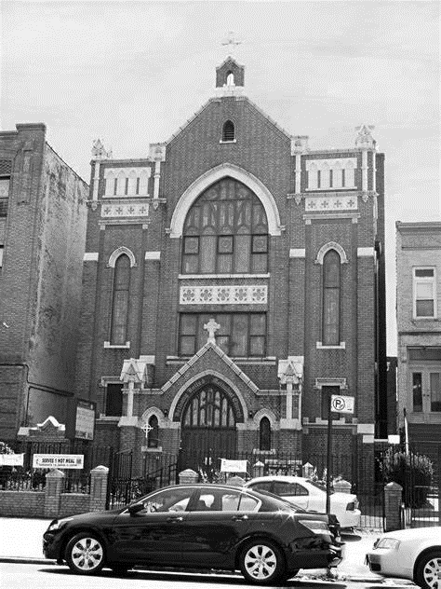
Thank you for worshipping with us.

